**Assignment 2**

1. Create an app that will change color of the screen and change the font size of the text.

**activity_main.xml**

<?xml version="1.0" encoding="utf-8"?>  
<RelativeLayout xmlns:android="http://schemas.android.com/apk/res/android"  
 xmlns:tools="http://schemas.android.com/tools"  
 android:layout_width="match_parent"  
 android:layout_height="match_parent"  
 android:paddingLeft="16dp"  
 android:paddingTop="16dp"  
 android:paddingRight="16dp"  
 android:paddingBottom="16dp"  
 tools:context=".MainActivity">  
  
 <Button  
 android:id="@+id/changeAppearanceButton"  
 android:layout_width="wrap_content"  
 android:layout_height="wrap_content"  
 android:text="Change Appearance"  
 android:layout_centerInParent="true"/>  
  
 <TextView  
 android:id="@+id/sampleText"  
 android:layout_width="wrap_content"  
 android:layout_height="wrap_content"  
 android:layout_below="@id/changeAppearanceButton"  
 android:layout_marginTop="16dp"  
 android:text="Hello, World!"  
 android:textSize="20sp"  
 android:textColor="@android:color/black"  
 android:layout_centerHorizontal="true"/>  
</RelativeLayout>

**ManiActivity.java**

package com.example.a5q1;  
  
import androidx.appcompat.app.AppCompatActivity;  
  
import android.graphics.Color;  
import android.os.Bundle;  
import android.view.View;  
import android.widget.Button;  
import android.widget.TextView;  
  
public class MainActivity extends AppCompatActivity {  
  
 private Button changeAppearanceButton;  
 private TextView sampleText;  
 private boolean isColorOne = true;  
  
 @Override  
 protected void onCreate(Bundle savedInstanceState) {  
 super.onCreate(savedInstanceState);  
 setContentView(R.layout.*activity_main*);  
  
 changeAppearanceButton = findViewById(R.id.*changeAppearanceButton*);  
 sampleText = findViewById(R.id.*sampleText*);  
  
 changeAppearanceButton.setOnClickListener(new View.OnClickListener() {  
 @Override  
 public void onClick(View view) {  
 changeAppearance();  
 }  
 });  
 }  
  
 private void changeAppearance() {  
 // Toggle between two colors and font sizes  
 if (isColorOne) {  
 sampleText.setTextColor(Color.*BLUE*);  
 sampleText.setTextSize(30);  
 } else {  
 sampleText.setTextColor(Color.*RED*);  
 sampleText.setTextSize(18);  
 }  
  
 isColorOne = !isColorOne;  
 }  
}

1. Create an app for the following: Average and Power

**activity_main.xml**

<?xml version="1.0" encoding="utf-8"?>  
<RelativeLayout xmlns:android="http://schemas.android.com/apk/res/android"  
 xmlns:tools="http://schemas.android.com/tools"  
 android:layout_width="match_parent"  
 android:layout_height="match_parent"  
 android:paddingLeft="16dp"  
 android:paddingTop="16dp"  
 android:paddingRight="16dp"  
 android:paddingBottom="16dp"  
 tools:context=".MainActivity">  
  
 <EditText  
 android:id="@+id/number1EditText"  
 android:layout_width="match_parent"  
 android:layout_height="wrap_content"  
 android:layout_marginBottom="8dp"  
 android:hint="Enter Number 1"  
 android:inputType="numberDecimal" />  
  
 <EditText  
 android:id="@+id/number2EditText"  
 android:layout_width="match_parent"  
 android:layout_height="wrap_content"  
 android:layout_below="@id/number1EditText"  
 android:layout_marginBottom="8dp"  
 android:hint="Enter Number 2"  
 android:inputType="numberDecimal" />  
  
 <Button  
 android:id="@+id/AverageButton"  
 android:layout_width="173dp"  
 android:layout_height="62dp"  
 android:layout_below="@id/number2EditText"  
 android:layout_alignParentStart="true"  
 android:layout_alignParentEnd="true"  
 android:layout_alignParentBottom="true"  
 android:layout_marginStart="139dp"  
 android:layout_marginTop="95dp"  
 android:layout_marginEnd="83dp"  
 android:layout_marginBottom="452dp"  
 android:text="Average" />  
  
 <Button  
 android:id="@+id/PowerButton"  
 android:layout_width="166dp"  
 android:layout_height="64dp"  
 android:layout_alignParentStart="true"  
 android:layout_alignParentTop="true"  
 android:layout_alignParentEnd="true"  
 android:layout_alignParentBottom="true"  
 android:layout_marginStart="120dp"  
 android:layout_marginTop="281dp"  
 android:layout_marginEnd="109dp"  
 android:layout_marginBottom="370dp"  
 android:text="Power" />  
  
 <TextView  
 android:id="@+id/ResultTextView"  
 android:layout_width="215dp"  
 android:layout_height="63dp"  
 android:layout_alignParentStart="true"  
 android:layout_alignParentTop="true"  
 android:layout_alignParentEnd="true"  
 android:layout_alignParentBottom="true"  
 android:layout_marginStart="34dp"  
 android:layout_marginTop="402dp"  
 android:layout_marginEnd="146dp"  
 android:layout_marginBottom="250dp"  
 android:text="Result: "  
 android:textColor="@android:color/black"  
 android:textSize="18sp" />  
</RelativeLayout>

**MainActivity.java**

package com.example.a5q2;  
  
import androidx.appcompat.app.AppCompatActivity;  
  
import android.os.Bundle;  
import android.view.View;  
import android.widget.Button;  
import android.widget.EditText;  
import android.widget.TextView;  
  
public class MainActivity extends AppCompatActivity {  
  
 private EditText number1EditText, number2EditText;  
 private Button AverageButton,PowerButton;  
 private TextView ResultTextView;  
  
 @Override  
 protected void onCreate(Bundle savedInstanceState) {  
 super.onCreate(savedInstanceState);  
 setContentView(R.layout.activity_main);  
  
 number1EditText = findViewById(R.id.number1EditText);  
 number2EditText = findViewById(R.id.number2EditText);  
 AverageButton = findViewById(R.id.AverageButton);  
 PowerButton = findViewById(R.id.PowerButton);  
 ResultTextView = findViewById(R.id.ResultTextView);  
  
 /*calculateButton = findViewById(R.id.calculateButton);  
 averageResultTextView = findViewById(R.id.averageResultTextView);  
 powerResultTextView = findViewById(R.id.powerResultTextView);*/  
  
 AverageButton.setOnClickListener(new View.OnClickListener() {  
 @Override  
 public void onClick(View view) {  
 double number1 = Double.parseDouble(number1EditText.getText().toString());  
 double number2 = Double.parseDouble(number2EditText.getText().toString());  
  
 // Calculate average  
 double average = (number1 + number2) / 2;  
 ResultTextView.setText("Average Result: " + average);  
 }  
 });  
  
 PowerButton.setOnClickListener(new View.OnClickListener() {  
 @Override  
 public void onClick(View view) {  
  
 double number1 = Double.*parseDouble*(number1EditText.getText().toString());  
 double number2 = Double.*parseDouble*(number2EditText.getText().toString());  
 double power = Math.*pow*(number1, number2);  
 ResultTextView.setText("Power Result: " + power);  
  
 }  
 });  
 }  
}

3.Create an app for string operations according to the selection:

(uppercase,lowercase,right5 chars,left5chars)

**activity_main.xml**

<?xml version="1.0" encoding="utf-8"?>  
<RelativeLayout xmlns:android="http://schemas.android.com/apk/res/android"  
 xmlns:tools="http://schemas.android.com/tools"  
 android:layout_width="match_parent"  
 android:layout_height="match_parent"  
 android:padding="16dp"  
 tools:context=".MainActivity">  
  
 <EditText  
 android:id="@+id/editTextInput"  
 android:layout_width="match_parent"  
 android:layout_height="wrap_content"  
 android:layout_below="@id/radioGroup"  
 android:layout_marginTop="16dp"  
 android:hint="Enter text"/>  
  
 <RadioGroup  
 android:id="@+id/radioGroup"  
 android:layout_width="wrap_content"  
 android:layout_height="wrap_content"  
 android:layout_centerHorizontal="true">  
  
 <RadioButton  
 android:id="@+id/radioUppercase"  
 android:layout_width="wrap_content"  
 android:layout_height="wrap_content"  
 android:checked="true"  
 android:text="Uppercase" />  
  
 <RadioButton  
 android:id="@+id/radioLowercase"  
 android:layout_width="wrap_content"  
 android:layout_height="wrap_content"  
 android:text="Lowercase" />  
  
 <RadioButton  
 android:id="@+id/radioRight5"  
 android:layout_width="wrap_content"  
 android:layout_height="wrap_content"  
 android:text="Right5" />  
  
 <RadioButton  
 android:id="@+id/radioLeft5"  
 android:layout_width="wrap_content"  
 android:layout_height="wrap_content"  
 android:text="Left5" />  
  
 </RadioGroup>  
  
  
 <Button  
 android:id="@+id/btnSubmit"  
 android:layout_width="match_parent"  
 android:layout_height="wrap_content"  
 android:layout_below="@id/editTextInput"  
 android:layout_marginTop="16dp"  
 android:text="Submit" />  
  
 <TextView  
 android:id="@+id/textOutput"  
 android:layout_width="match_parent"  
 android:layout_height="wrap_content"  
 android:layout_below="@id/btnSubmit"  
 android:layout_marginTop="16dp" />  
  
</RelativeLayout>

**MainActivity.java**

package com.example.a5q3;  
  
import androidx.appcompat.app.AppCompatActivity;  
  
import android.os.Bundle;  
import android.view.View;  
import android.widget.Button;  
import android.widget.EditText;  
import android.widget.RadioButton;  
import android.widget.RadioGroup;  
import android.widget.TextView;  
import android.widget.Toast;  
  
public class MainActivity extends AppCompatActivity {  
  
 RadioGroup radioGroup;  
 EditText editTextInput;  
 Button btnSubmit;  
 TextView textOutput;  
  
 @Override  
 protected void onCreate(Bundle savedInstanceState) {  
 super.onCreate(savedInstanceState);  
 setContentView(R.layout.*activity_main*);  
  
 editTextInput = findViewById(R.id.*editTextInput*);  
 radioGroup = findViewById(R.id.*radioGroup*);  
 btnSubmit = findViewById(R.id.*btnSubmit*);  
 textOutput = findViewById(R.id.*textOutput*);  
  
 btnSubmit.setOnClickListener(new View.OnClickListener() {  
 @Override  
 public void onClick(View view) {  
 performOperation();  
 }  
 });  
 }  
 private void performOperation() {  
 int selectedRadioButtonId = radioGroup.getCheckedRadioButtonId();  
 RadioButton selectedRadioButton = findViewById(selectedRadioButtonId);  
  
 String inputText = editTextInput.getText().toString();  
 String outputText;  
  
 if (selectedRadioButton.getId() == R.id.*radioUppercase*) {  
 outputText = inputText.toUpperCase();  
 } else if (selectedRadioButton.getId() == R.id.*radioLowercase*) {  
 outputText = inputText.toLowerCase();  
 }  
 else if (selectedRadioButton.getId() == R.id.*radioRight5*){  
 int length = inputText.length();  
 outputText = inputText.substring(length - 5) ;  
 }  
 else if (selectedRadioButton.getId() == R.id.*radioLeft5*){  
 int length = inputText.length();  
 outputText = inputText.substring(0,5);  
 }  
 else  
 {  
 // Handle other cases if needed  
 outputText = "Invalid Operation";  
 }  
  
 textOutput.setText("Output: " + outputText);  
 }  
}

4.Create an app for an array list operators:Union,Intersection,merge

**activity_main.xml**

<?xml version="1.0" encoding="utf-8"?>  
<RelativeLayout xmlns:android="http://schemas.android.com/apk/res/android"  
 xmlns:tools="http://schemas.android.com/tools"  
 android:layout_width="match_parent"  
 android:layout_height="match_parent"  
 android:padding="16dp"  
 tools:context=".MainActivity">  
  
 <EditText  
 android:id="@+id/editList1"  
 android:layout_width="match_parent"  
 android:layout_height="wrap_content"  
 android:hint="Enter list 1 (comma-separated)"  
 android:inputType="text"/>  
  
 <EditText  
 android:id="@+id/editList2"  
 android:layout_width="match_parent"  
 android:layout_height="wrap_content"  
 android:layout_below="@id/editList1"  
 android:layout_marginTop="16dp"  
 android:hint="Enter list 2 (comma-separated)"  
 android:inputType="text"/>  
  
 <Button  
 android:id="@+id/btnUnion"  
 android:layout_width="231dp"  
 android:layout_height="wrap_content"  
 android:layout_below="@id/editList2"  
 android:layout_alignParentStart="true"  
 android:layout_alignParentEnd="true"  
 android:layout_marginStart="117dp"  
 android:layout_marginTop="47dp"  
 android:layout_marginEnd="110dp"  
 android:text="Union" />  
  
 <Button  
 android:id="@+id/btnIntersection"  
 android:layout_width="188dp"  
 android:layout_height="wrap_content"  
 android:layout_below="@id/btnUnion"  
 android:layout_alignParentStart="true"  
 android:layout_alignParentEnd="true"  
 android:layout_marginStart="113dp"  
 android:layout_marginTop="37dp"  
 android:layout_marginEnd="94dp"  
 android:text="Intersection" />  
  
 <Button  
 android:id="@+id/btnMerge"  
 android:layout_width="133dp"  
 android:layout_height="wrap_content"  
 android:layout_below="@id/btnIntersection"  
 android:layout_alignParentStart="true"  
 android:layout_alignParentEnd="true"  
 android:layout_marginStart="114dp"  
 android:layout_marginTop="32dp"  
 android:layout_marginEnd="149dp"  
 android:text="Merge" />  
  
 <TextView  
 android:id="@+id/textResult"  
 android:layout_width="match_parent"  
 android:layout_height="wrap_content"  
 android:layout_below="@id/btnMerge"  
 android:layout_marginTop="16dp" />  
  
</RelativeLayout>

**MainActivity.java**

package com.example.radiobutton;  
  
import androidx.appcompat.app.AppCompatActivity;  
  
import android.os.Bundle;  
import android.view.View;  
import android.widget.Button;  
import android.widget.EditText;  
import android.widget.RadioButton;  
import android.widget.RadioGroup;  
import android.widget.TextView;  
  
import java.util.ArrayList;  
import java.util.HashSet;  
import java.util.Set;  
  
public class MainActivity extends AppCompatActivity {  
  
 private EditText editList1, editList2;  
 private Button btnUnion, btnIntersection, btnMerge;  
 private TextView textResult;  
  
 @Override  
 protected void onCreate(Bundle savedInstanceState) {  
 super.onCreate(savedInstanceState);  
 setContentView(R.layout.*activity_main*);  
  
 editList1 = findViewById(R.id.*editList1*);  
 editList2 = findViewById(R.id.*editList2*);  
 btnUnion = findViewById(R.id.*btnUnion*);  
 btnIntersection = findViewById(R.id.*btnIntersection*);  
 btnMerge = findViewById(R.id.*btnMerge*);  
 textResult = findViewById(R.id.*textResult*);  
  
 btnUnion.setOnClickListener(new View.OnClickListener() {  
 @Override  
 public void onClick(View view) {  
 ArrayList<String> list1 = getListFromEditText(editList1);  
 ArrayList<String> list2 = getListFromEditText(editList2);  
  
 Set<String> unionSet = new HashSet<>(list1);  
 unionSet.addAll(list2);  
  
 displayResult(unionSet);  
 }  
 });  
  
 btnIntersection.setOnClickListener(new View.OnClickListener() {  
 @Override  
 public void onClick(View view) {  
 ArrayList<String> list1 = getListFromEditText(editList1);  
 ArrayList<String> list2 = getListFromEditText(editList2);  
  
 Set<String> intersectionSet = new HashSet<>(list1);  
 intersectionSet.retainAll(list2);  
  
 displayResult(intersectionSet);  
 }  
 });  
  
  
 btnMerge.setOnClickListener(new View.OnClickListener() {  
 @Override  
 public void onClick(View view) {  
 ArrayList<String> list1 = getListFromEditText(editList1);  
 ArrayList<String> list2 = getListFromEditText(editList2);  
  
 list1.addAll(list2);  
  
 displayResult(new HashSet<>(list1));  
 }  
 });  
 }  
 private ArrayList<String> getListFromEditText(EditText editText) {  
 String input = editText.getText().toString().trim();  
 String[] items = input.split(",");  
 ArrayList<String> list = new ArrayList<>();  
  
 for (String item : items) {  
 list.add(item.trim());  
 }  
  
 return list;  
 }  
  
 private void displayResult(Set<String> resultSet) {  
 StringBuilder resultText = new StringBuilder("Result: ");  
  
 for (String item : resultSet) {  
 resultText.append(item).append(", ");  
 }  
  
 if (resultText.length() > 0) {  
 resultText.delete(resultText.length() - 2, resultText.length());  
 } else {  
 resultText.append("Empty");  
 }  
  
 textResult.setText(resultText.toString());  
 }  
}

6. Create an app to read 5 numbers and find: Sum and Average

**activity_main.xml**

<?xml version="1.0" encoding="utf-8"?>  
<RelativeLayout xmlns:android="http://schemas.android.com/apk/res/android"  
 xmlns:tools="http://schemas.android.com/tools"  
 android:layout_width="match_parent"  
 android:layout_height="match_parent"  
 android:paddingLeft="16dp"  
 android:paddingTop="16dp"  
 android:paddingRight="16dp"  
 android:paddingBottom="16dp"  
 tools:context=".MainActivity">  
  
 <EditText  
 android:id="@+id/editTextNumber1"  
 android:layout_width="match_parent"  
 android:layout_height="wrap_content"  
 android:inputType="numberDecimal"  
 android:hint="Enter Number 1"/>  
  
 <EditText  
 android:id="@+id/editTextNumber2"  
 android:layout_width="match_parent"  
 android:layout_height="wrap_content"  
 android:inputType="numberDecimal"  
 android:layout_below="@id/editTextNumber1"  
 android:hint="Enter Number 2"/>  
  
 <EditText  
 android:id="@+id/editTextNumber3"  
 android:layout_width="match_parent"  
 android:layout_height="wrap_content"  
 android:inputType="numberDecimal"  
 android:layout_below="@id/editTextNumber2"  
 android:hint="Enter Number 3"/>  
  
 <EditText  
 android:id="@+id/editTextNumber4"  
 android:layout_width="match_parent"  
 android:layout_height="wrap_content"  
 android:inputType="numberDecimal"  
 android:layout_below="@id/editTextNumber3"  
 android:hint="Enter Number 4"/>  
  
 <EditText  
 android:id="@+id/editTextNumber5"  
 android:layout_width="match_parent"  
 android:layout_height="wrap_content"  
 android:inputType="numberDecimal"  
 android:layout_below="@id/editTextNumber4"  
 android:hint="Enter Number 5"/>  
  
 <Button  
 android:id="@+id/btnCalculate"  
 android:layout_width="wrap_content"  
 android:layout_height="wrap_content"  
 android:layout_below="@id/editTextNumber5"  
 android:layout_marginTop="16dp"  
 android:text="Calculate"/>  
  
 <TextView  
 android:id="@+id/textViewResult"  
 android:layout_width="wrap_content"  
 android:layout_height="wrap_content"  
 android:layout_below="@id/btnCalculate"  
 android:layout_marginTop="16dp"/>  
</RelativeLayout>

**MainActivity.java**

package com.example.a5q6;  
  
import androidx.appcompat.app.AppCompatActivity;  
  
import android.os.Bundle;  
import android.view.View;  
import android.widget.Button;  
import android.widget.EditText;  
import android.widget.TextView;  
  
public class MainActivity extends AppCompatActivity {  
  
 @Override  
 protected void onCreate(Bundle savedInstanceState) {  
 super.onCreate(savedInstanceState);  
 setContentView(R.layout.activity_main);  
  
 final EditText[] editTextNumbers = new EditText[5];  
 editTextNumbers[0] = findViewById(R.id.editTextNumber1);  
 editTextNumbers[1] = findViewById(R.id.editTextNumber2);  
 editTextNumbers[2] = findViewById(R.id.editTextNumber3);  
 editTextNumbers[3] = findViewById(R.id.editTextNumber4);  
 editTextNumbers[4] = findViewById(R.id.editTextNumber5);  
  
 Button btnCalculate = findViewById(R.id.btnCalculate);  
 final TextView textViewResult = findViewById(R.id.textViewResult);  
  
 btnCalculate.setOnClickListener(new View.OnClickListener() {  
 @Override  
 public void onClick(View view) {  
 double sum = 0;  
 double average;  
  
 for (EditText editText : editTextNumbers) {  
 String strNumber = editText.getText().toString();  
 if (!strNumber.isEmpty()) {  
 sum += Double.parseDouble(strNumber);  
 }  
 }  
 if (sum != 0) {  
 average = sum / 5;  
 String result = "Sum: " + sum + "\nAverage: " + average;  
 textViewResult.setText(result);  
 } else {  
 textViewResult.setText("Please enter at least one number.");  
 }  
 }  
 });  
  
 }  
}

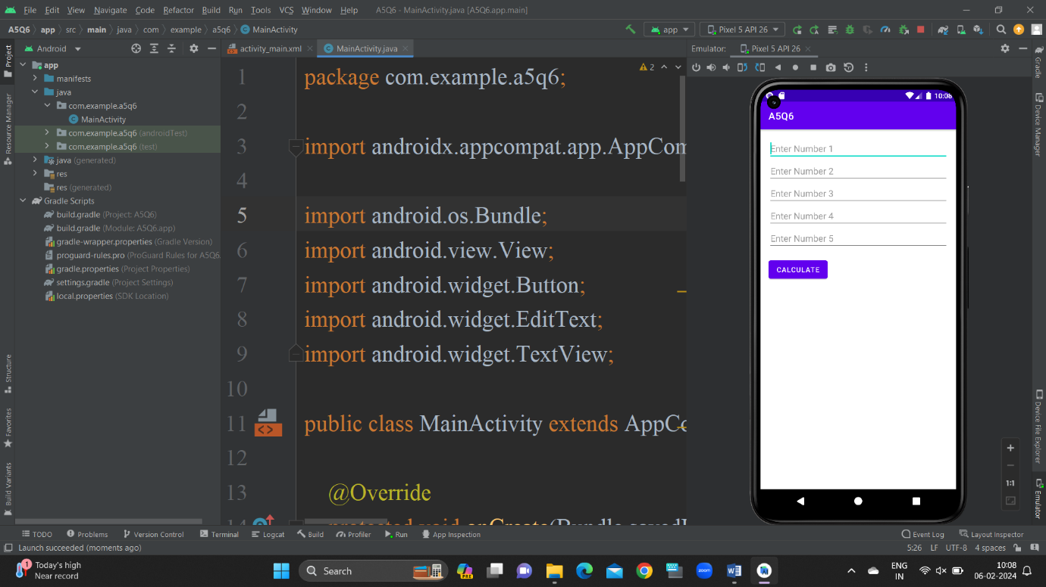 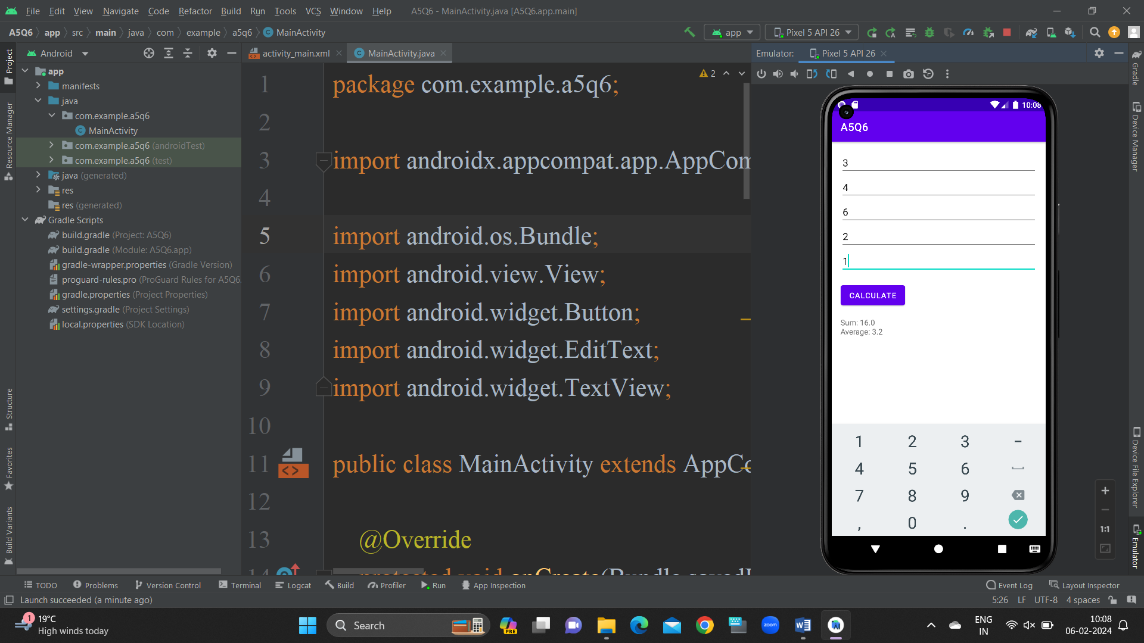

7. Create an android app to accept a number and calculate Factorial, Armstrong, sum of digit and perfect number using menu.

**activity_main.xml**

<RelativeLayout xmlns:android="http://schemas.android.com/apk/res/android"  
 xmlns:tools="http://schemas.android.com/tools"  
 android:layout_width="match_parent"  
 android:layout_height="match_parent"  
 tools:context=".MainActivity">  
  
 <EditText  
 android:id="@+id/inputNumber"  
 android:layout_width="match_parent"  
 android:layout_height="wrap_content"  
 android:hint="Enter a number"  
 android:inputType="number"  
 android:layout_margin="16dp"/>  
  
 <Button  
 android:id="@+id/btnFactorial"  
 android:layout_width="wrap_content"  
 android:layout_height="wrap_content"  
 android:layout_below="@id/inputNumber"  
 android:layout_marginTop="8dp"  
 android:onClick="calculate"  
 android:text="Factorial"/>  
  
 <Button  
 android:id="@+id/btnArmstrong"  
 android:layout_width="wrap_content"  
 android:layout_height="wrap_content"  
 android:layout_below="@id/btnFactorial"  
 android:layout_marginTop="8dp"  
 android:onClick="calculate"  
 android:text="Armstrong"/>  
  
 <Button  
 android:id="@+id/btnSumOfDigits"  
 android:layout_width="wrap_content"  
 android:layout_height="wrap_content"  
 android:layout_below="@id/btnArmstrong"  
 android:layout_marginTop="8dp"  
 android:onClick="calculate"  
 android:text="Sum of Digits"/>  
  
 <Button  
 android:id="@+id/btnPerfectNumber"  
 android:layout_width="wrap_content"  
 android:layout_height="wrap_content"  
 android:layout_below="@id/btnSumOfDigits"  
 android:layout_marginTop="8dp"  
 android:onClick="calculate"  
 android:text="Perfect Number"/>  
  
 <TextView  
 android:id="@+id/resultText"  
 android:layout_width="wrap_content"  
 android:layout_height="wrap_content"  
 android:layout_below="@id/btnPerfectNumber"  
 android:layout_marginTop="16dp"  
 android:text=""  
 android:textSize="18sp"/>  
</RelativeLayout>

**MainActivity.java**

package com.example.a5q7;  
  
import androidx.appcompat.app.AppCompatActivity;  
  
import android.os.Bundle;  
import android.view.View;  
import android.widget.EditText;  
import android.widget.TextView;  
  
public class MainActivity extends AppCompatActivity {  
  
 EditText inputNumber;  
 TextView resultText;  
  
 @Override  
 protected void onCreate(Bundle savedInstanceState) {  
 super.onCreate(savedInstanceState);  
 setContentView(R.layout.*activity_main*);  
  
 inputNumber = findViewById(R.id.*inputNumber*);  
 resultText = findViewById(R.id.*resultText*);  
 }  
  
 public void calculate(View view) {  
 String numberStr = inputNumber.getText().toString();  
  
 if (!numberStr.isEmpty()) {  
 int number = Integer.*parseInt*(numberStr);  
  
 switch (view.getId()) {  
 case R.id.*btnFactorial*:  
 long factorialResult = calculateFactorial(number);  
 displayResult("Factorial: " + factorialResult);  
 break;  
  
 case R.id.*btnArmstrong*:  
 boolean armstrongResult = isArmstrong(number);  
 displayResult("Armstrong: " + armstrongResult);  
 break;  
  
 case R.id.*btnSumOfDigits*:  
 int sumOfDigitsResult = calculateSumOfDigits(number);  
 displayResult("Sum of Digits: " + sumOfDigitsResult);  
 break;  
  
 case R.id.*btnPerfectNumber*:  
 boolean perfectNumberResult = isPerfectNumber(number);  
 displayResult("Perfect Number: " + perfectNumberResult);  
 break;  
 }  
 } else {  
 displayResult("Please enter a number");  
 }  
 }  
  
 private long calculateFactorial(int n) {  
 if (n == 0 || n == 1) {  
 return 1;  
 }  
 return n * calculateFactorial(n - 1);  
 }  
  
 private boolean isArmstrong(int n) {  
 int originalNumber = n;  
 int sum = 0;  
 while (n > 0) {  
 int digit = n % 10;  
 sum += Math.*pow*(digit, 3); // For a 3-digit Armstrong number  
 n /= 10;  
 }  
 return sum == originalNumber;  
 }  
  
 private int calculateSumOfDigits(int n) {  
 int sum = 0;  
 while (n > 0) {  
 sum += n % 10;  
 n /= 10;  
 }  
 return sum;  
 }  
  
 private boolean isPerfectNumber(int n) {  
 int sum = 1;  
 for (int i = 2; i * i <= n; i++) {  
 if (n % i == 0) {  
 sum += i;  
 if (i != n / i) {  
 sum += n / i;  
 }  
 }  
 }  
 return sum == n;  
 }  
  
 private void displayResult(String result) {  
 resultText.setText(result);  
 }  
}

8. Accept 2 numbers and display them but reject if both numbers are less than 10 and ask for new 2 numbers.

**activity_main.xml**

<?xml version="1.0" encoding="utf-8"?>  
<androidx.constraintlayout.widget.ConstraintLayout xmlns:android="http://schemas.android.com/apk/res/android"  
 xmlns:app="http://schemas.android.com/apk/res-auto"  
 xmlns:tools="http://schemas.android.com/tools"  
 android:layout_width="match_parent"  
 android:layout_height="match_parent"  
 tools:context=".MainActivity">  
  
 <EditText  
 android:id="@+id/editTextNum1"  
 android:layout_width="wrap_content"  
 android:layout_height="wrap_content"  
 android:ems="10"  
 android:inputType="textPersonName"  
 android:hint="Enter 1st number"  
 app:layout_constraintBottom_toBottomOf="parent"  
 app:layout_constraintEnd_toEndOf="parent"  
 app:layout_constraintHorizontal_bias="0.333"  
 app:layout_constraintStart_toStartOf="parent"  
 app:layout_constraintTop_toTopOf="parent"  
 app:layout_constraintVertical_bias="0.08" />  
  
 <EditText  
 android:id="@+id/editTextNum2"  
 android:layout_width="wrap_content"  
 android:layout_height="wrap_content"  
 android:ems="10"  
 android:hint="Enter 2nd number"  
 android:inputType="textPersonName"  
 app:layout_constraintBottom_toBottomOf="parent"  
 app:layout_constraintEnd_toEndOf="parent"  
 app:layout_constraintHorizontal_bias="0.333"  
 app:layout_constraintStart_toStartOf="parent"  
 app:layout_constraintTop_toTopOf="parent"  
 app:layout_constraintVertical_bias="0.185" />  
  
 <TextView  
 android:id="@+id/textViewResult"  
 android:layout_width="313dp"  
 android:layout_height="64dp"  
 android:text="Result is:"  
 app:layout_constraintBottom_toBottomOf="parent"  
 app:layout_constraintEnd_toEndOf="parent"  
 app:layout_constraintHorizontal_bias="0.387"  
 app:layout_constraintStart_toStartOf="parent"  
 app:layout_constraintTop_toTopOf="parent"  
 app:layout_constraintVertical_bias="0.406" />  
  
 <Button  
 android:id="@+id/btndisplay"  
 android:layout_width="wrap_content"  
 android:layout_height="wrap_content"  
 android:text="Display"  
 app:layout_constraintBottom_toBottomOf="parent"  
 app:layout_constraintEnd_toEndOf="parent"  
 app:layout_constraintHorizontal_bias="0.401"  
 app:layout_constraintStart_toStartOf="parent"  
 app:layout_constraintTop_toTopOf="parent"  
 app:layout_constraintVertical_bias="0.285" />  
</androidx.constraintlayout.widget.ConstraintLayout>

**MainActivity.java**

package com.example.a5q8;  
  
import androidx.appcompat.app.AppCompatActivity;  
  
import android.os.Bundle;  
import android.view.View;  
import android.widget.Button;  
import android.widget.EditText;  
import android.widget.TextView;  
import android.widget.Toast;  
  
public class MainActivity extends AppCompatActivity {  
  
 EditText editTextNum1,editTextNum2;  
 TextView textViewResult;  
 Button btndisplay;  
  
 @Override  
 protected void onCreate(Bundle savedInstanceState) {  
 super.onCreate(savedInstanceState);  
 setContentView(R.layout.activity_main);  
  
 editTextNum1 = findViewById(R.id.editTextNum1);  
 editTextNum2 = findViewById(R.id.editTextNum2);  
 textViewResult = findViewById(R.id.textViewResult);  
 btndisplay = findViewById(R.id.btndisplay);  
  
 btndisplay.setOnClickListener(new View.OnClickListener() {  
 @Override  
 public void onClick(View view) {  
 int Num1 = Integer.*parseInt*(editTextNum1.getText().toString());  
 int Num2 = Integer.*parseInt*(editTextNum2.getText().toString());  
 if(Num1<10 && Num2<10)  
 {  
 Toast.*makeText*(MainActivity.this, "Please Enter correct value greater than 10", Toast.*LENGTH_SHORT*).show();  
 }  
 else{  
 textViewResult.setText("Num1:"+Num1 + "and Num2:"+Num2);  
 }  
 }  
 });  
 }  
}

